**Business**  **Process** Documentation

**Nusantara Application Certification (NAS)**



|  |
| --- |
| Prepared by: |
| **PT. Nusantara Success Technology**  Jl. Jati Murni No. 30, Jati Padang, Sunday Market  South Jakarta 12540 |



# **Document** version

|  |  |  |  |
| --- | --- | --- | --- |
|  |  |  |  |
| Document Description | 1st Publish |  |  |
|  |  |  |  |
| Document Change history |  |  |  |
| Date | Created by | Verses | Description of changes |
| 24 February 2020 i | WN | 1.1 | Mobile version OF MVP NAS asesi |
|  |  |  |  |
|  |  |  |  |
|  |  |  |  |
|  |  |  |  |
|  |  |  |  |

# **Approval** page

|  |  |  |  |
| --- | --- | --- | --- |
| **PT. Nusantara Sukses Teknologi** | | **Pt. Nusantara Sertimedia Application** | |
| Prepared by: | Approved by: | Review by: | Approved by: |
| Windy |  |  |  |
| Date: | Date: | Date: | Date: |

Nusantara Application Certification

Business Process Documentation

This document is used to describe the workflow and business process of the Nusantara certification application (NAS). Dokumen This document is an Advanced version of the previousversion, namely version 1.1 (Minimum Viable Product) that describes the business process Mobile asesi

# Flow & Activity Diagram

This section describes the flow/ business processes that occur in the NAS application .

**Flow Diagram in general**

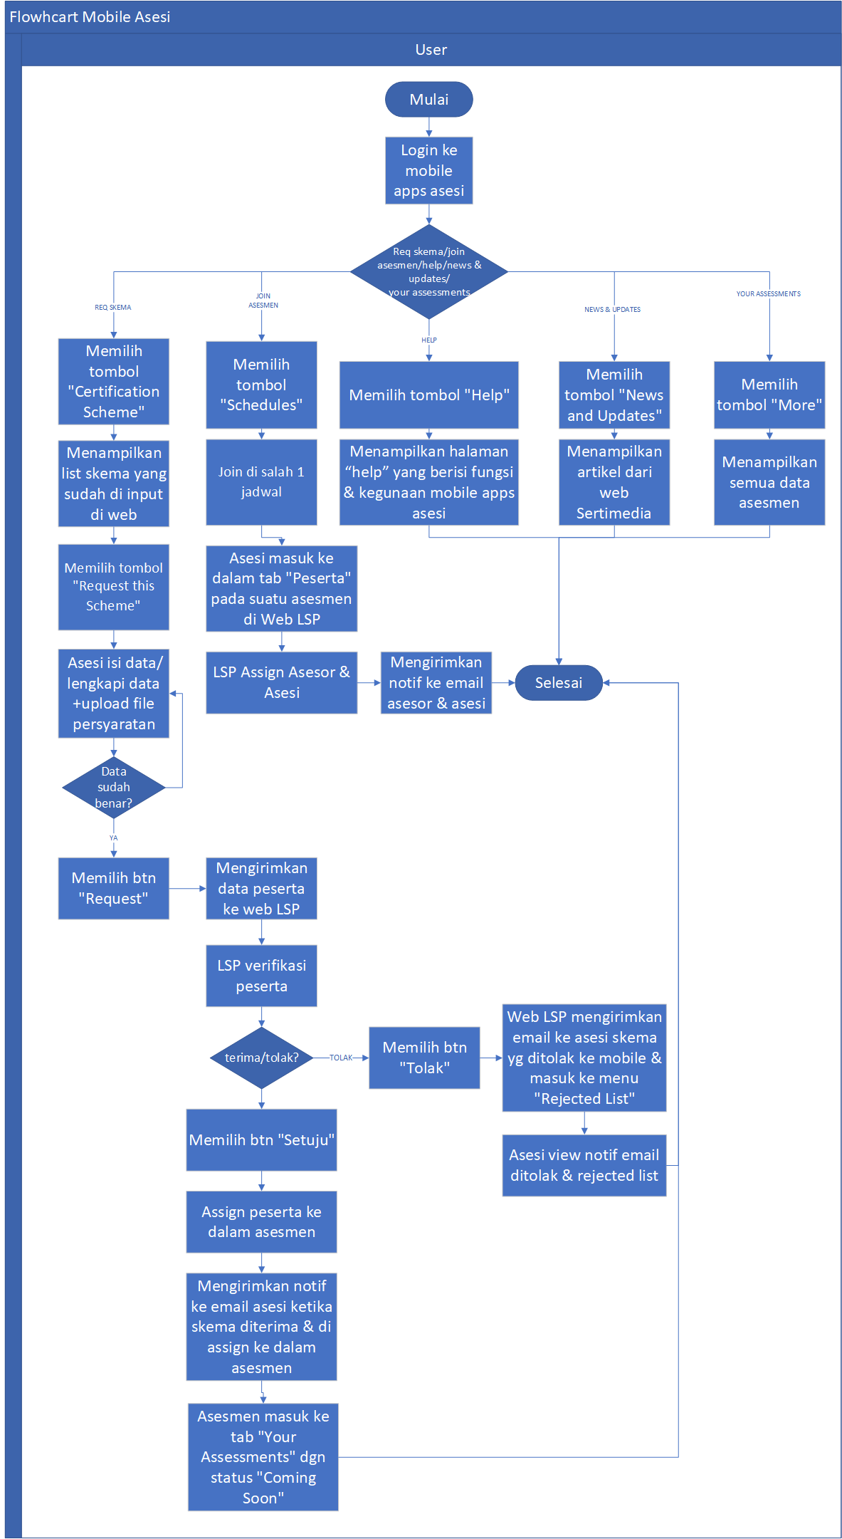

**Flow Diagram Mobile**  **asesi**

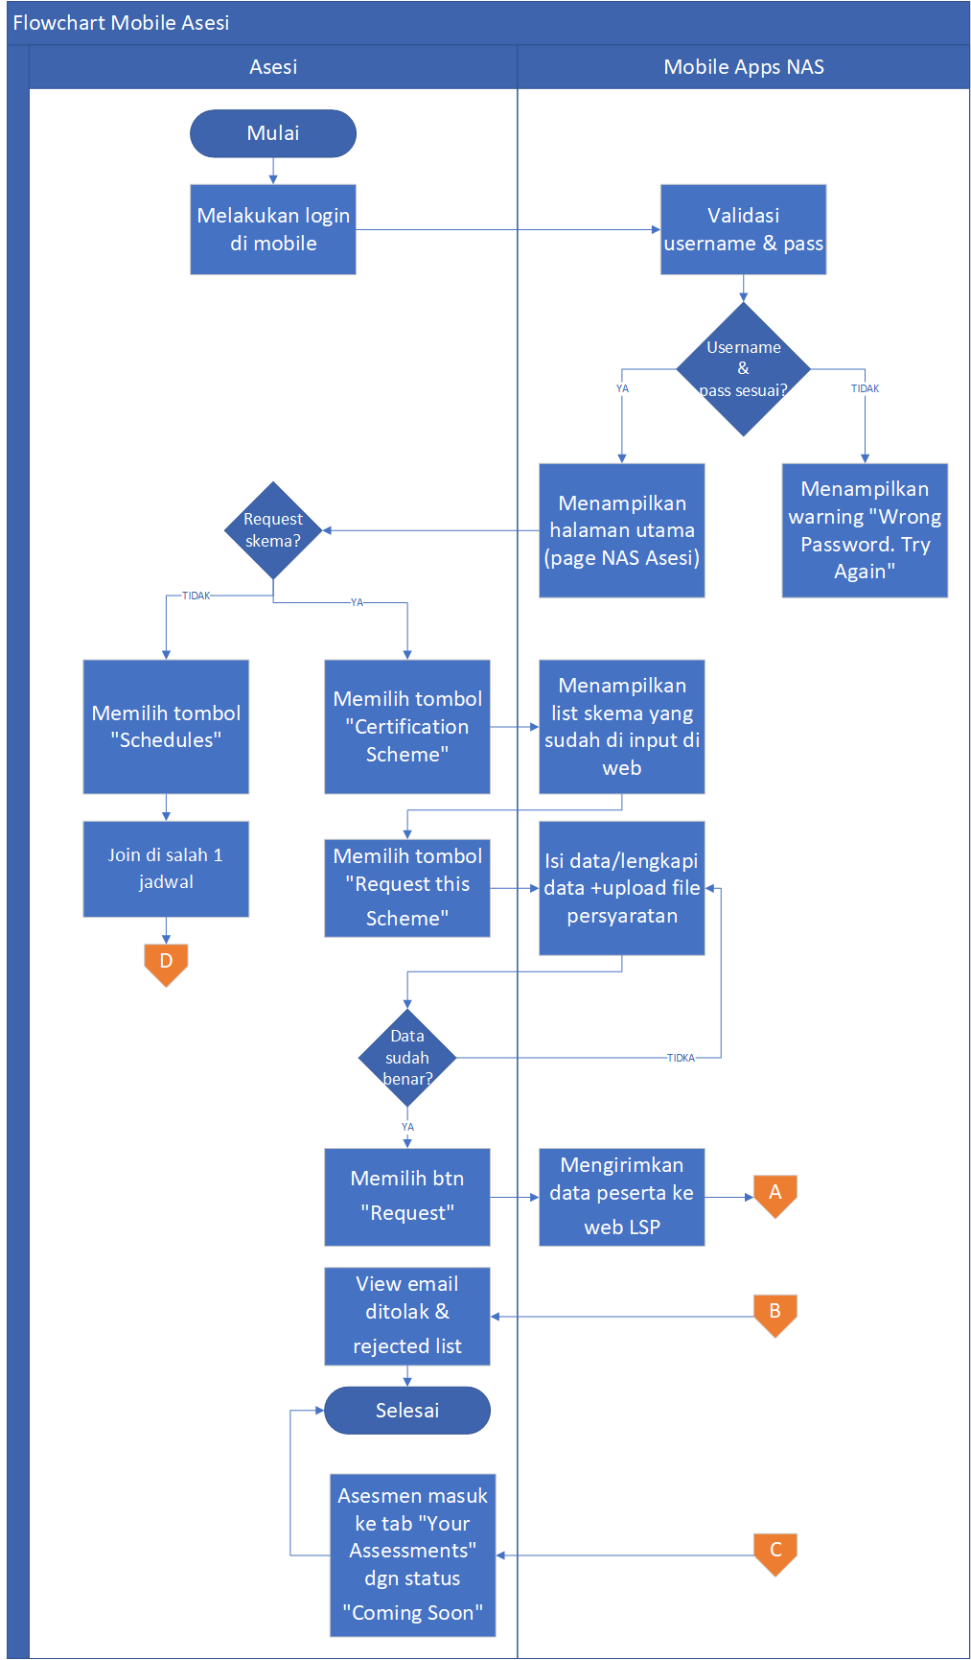

**Flow Diagram LSP**

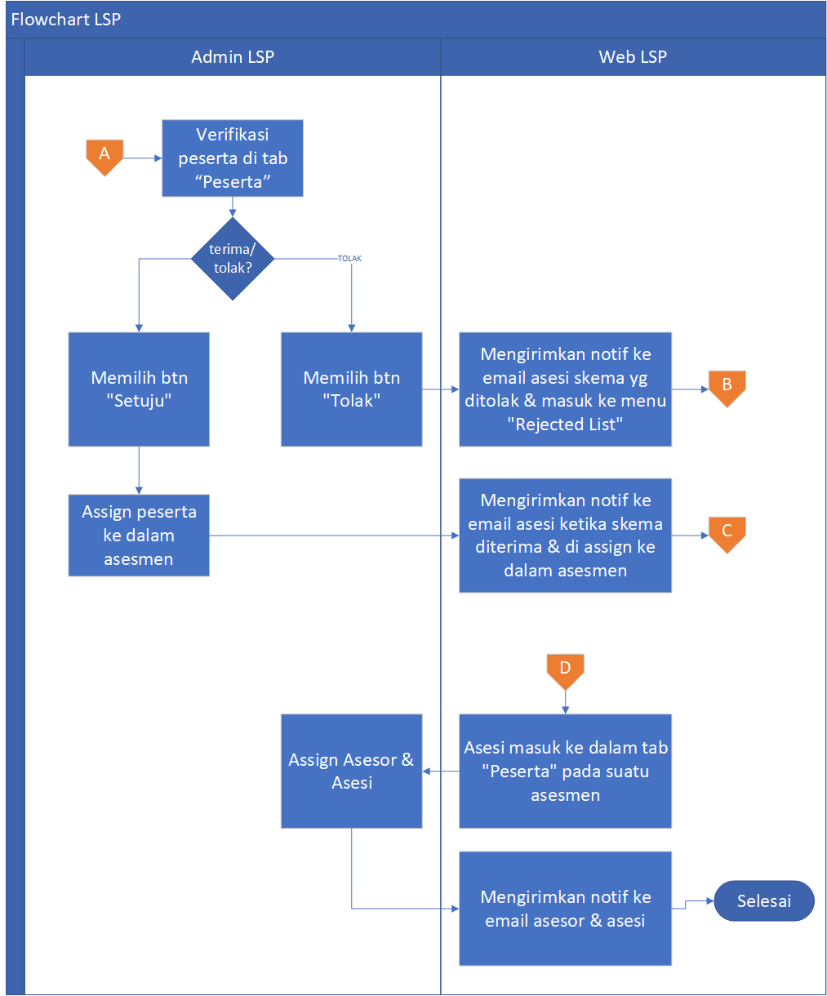

**Activity Diagram NAS Mobile Apps**  **asesi**

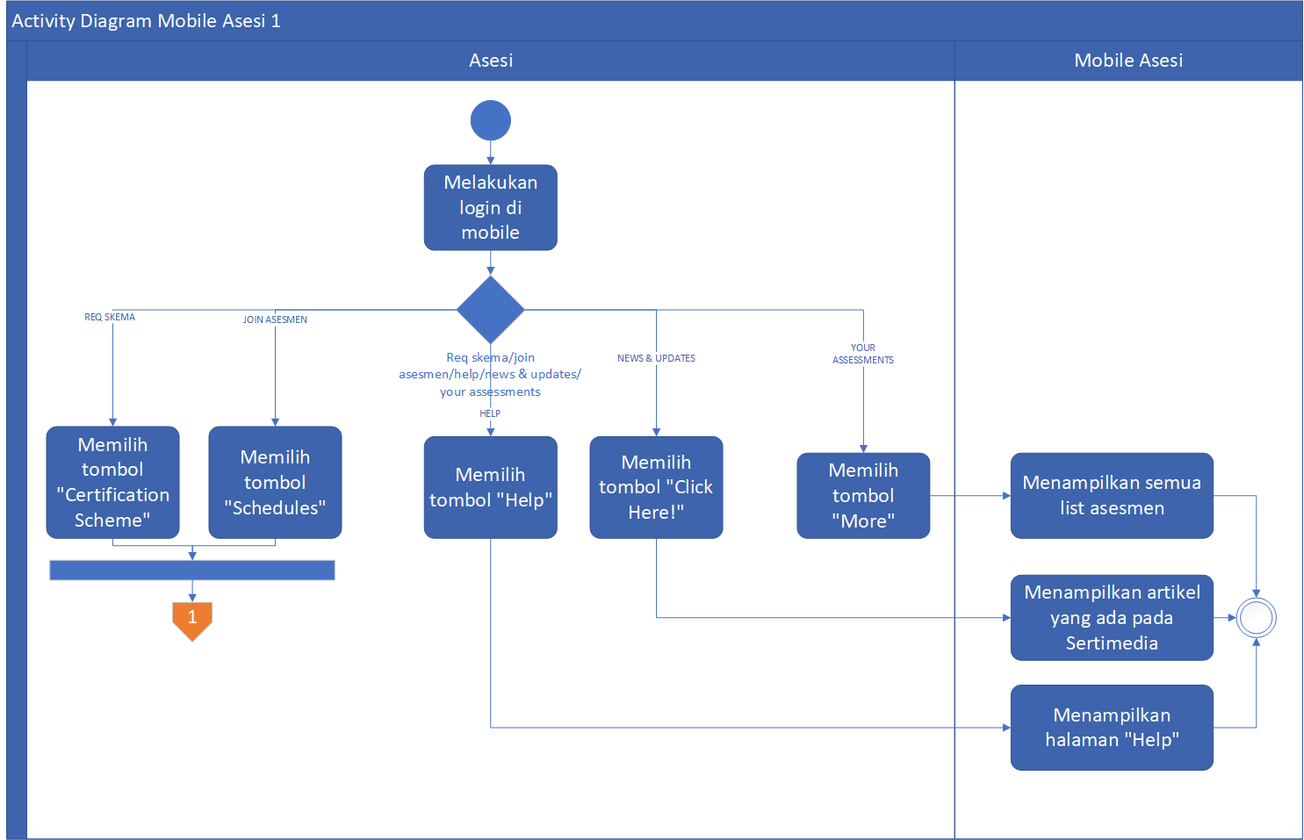

**Activity Diagram Mobile Apps**  **asesi**  **2**

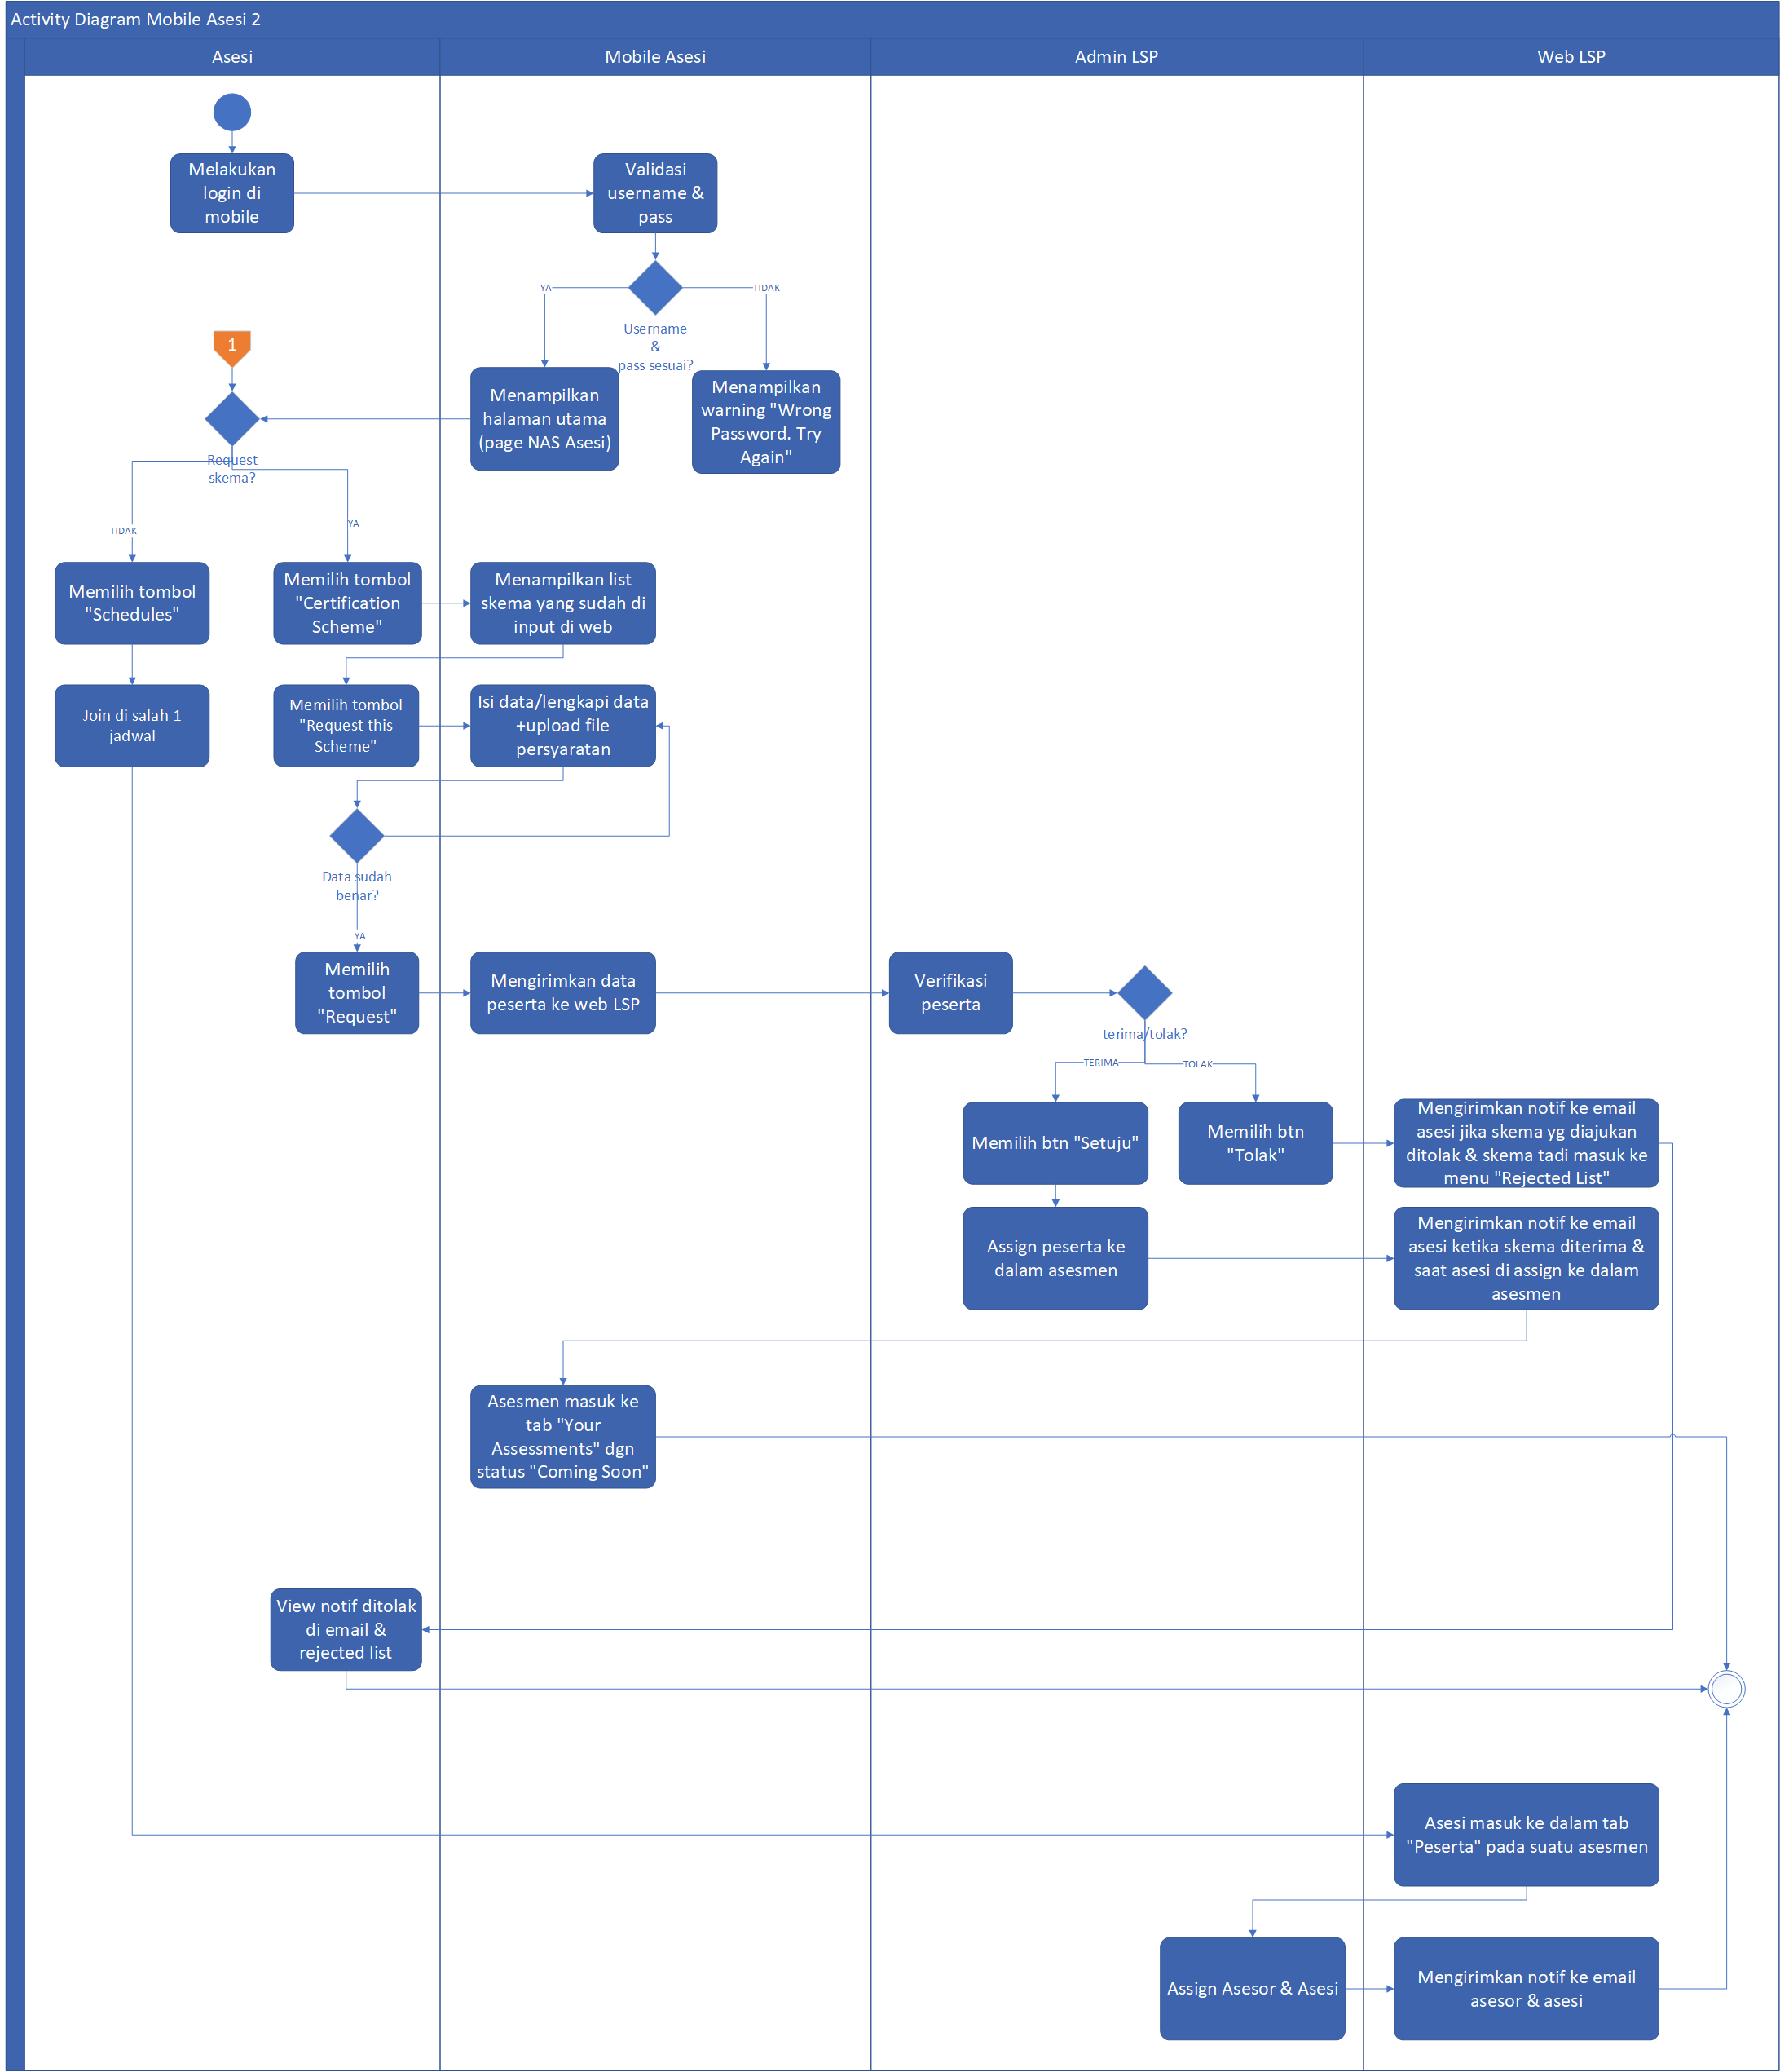

## Description

1. Participants login to the mobile apps and
2. Participants can choose to request a schema or join to the assessment
3. If the participant has requested a scheme then The submission will be entered on the Web LSP in the menu "participant" but if and directly apply to The assessment will be held then the and will be listed As a participant in the "attendees" tab of the assessment that will take place. asesmen
4. LSP Admins can refuse/accept The schema in the request by the participant in the "attendees"menu. If "agreed", the LSP admin can assign peserta the participant to the assessment using the scheme that the participantrequests. When already assigned, the and will get a notif that the scheme in the request has been approved by the admin & will get a notif that and is already a participant in an assessment. If the admin of LSP assign "participant" to be "asesi" to an assessor, then the asesi will get a notification that it was assigned to an assessment on the date of the with the name of the accessories listed. When the LSP admin rejects the schema in the request, the participant will get a notif that the scheme was rejected & The schema that was rejected would go to the "Rejected list" list. If "disagree ", skema the req scheme by the participant will go to the list of "Rejected list" on mobile and.

Use Case Diagram

In this section will be described the Authority of each user involved. Here 's a user rights Chart on the application NAS Mobile apps asesi :

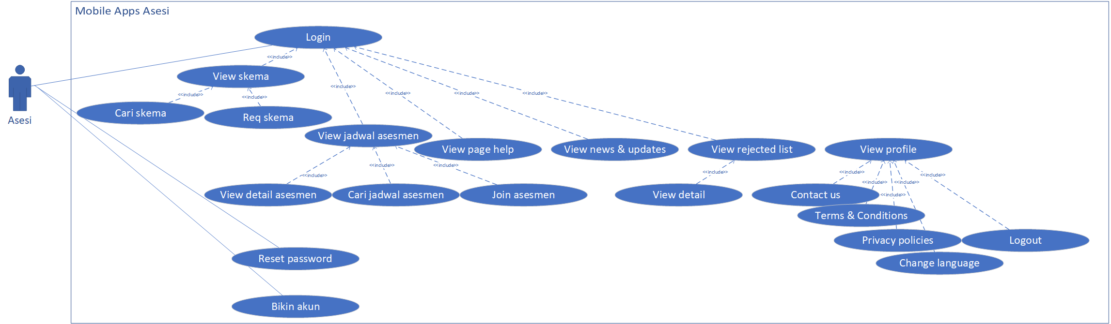

In Mobile Apps, asesi can perform the followingprocess:

1. Login
2. View, search, request schema
3. View Schedules, details, search schedules, and join asesmen existing sudah Assessment
4. View page help
5. View page news & updates
6. View menu rejected list, dan view detail rejected list
7. View profile, contact us, terms & conditions, privacy policies, change language, dan logout

## Menu List/Features

|  |  |  |  |  |  |  |  |
| --- | --- | --- | --- | --- | --- | --- | --- |
| **No** | **Module** | **Sub Modules** | **Description** | **User** | **Platform** | | **Type** |
| **And** | **Web** | **Mobile** |  |
| 1. | Home | Certification Scheme | This Menu is used to view the existing schema (which is already in the Create by LSP) | V |  | V | View skema certification scheme |
| Schedules | This Menu is used to view the schedule of existing assessment (which is already in the Create by LSP or that has been upgraded by TUK) | V |  | V | View jadwal Assessment Schedule |
| Help | This Menu is used to view The procedure for How to use applications | V |  | V | View |
| News and Updates | This Menu is used to view The news in Sertimedia | V |  | V | View |
| Your Assessments | This Menu is used to view all the assessment lists | V |  | V | View list assessments, view detail assessments |
| 2. | Rejected List |  | This Menu is used for view schema rejected by LSP | V |  | V | View list, view detail rejected |
| 3. | Profile | Contact Us | This Menu is used to send messages to the Customer Care NAS | V |  | V | Create |
| Terms & Conditions | This Menu is used to view the terms & application terms of Use | V |  | V | View |
| Privacy Policies | This Menu is used for view kebijakan privacy Policy | V |  | V | View |
| Change Language | This Menu is used to change the language to be used in mobile apps and | V |  | V | - |
| Logout | This Menu is used to quit the and application | V |  | V | - |

## Mobile Design

Here is an example of Design display aplikasi NAS application on the asesi Login

1. **Login** Page

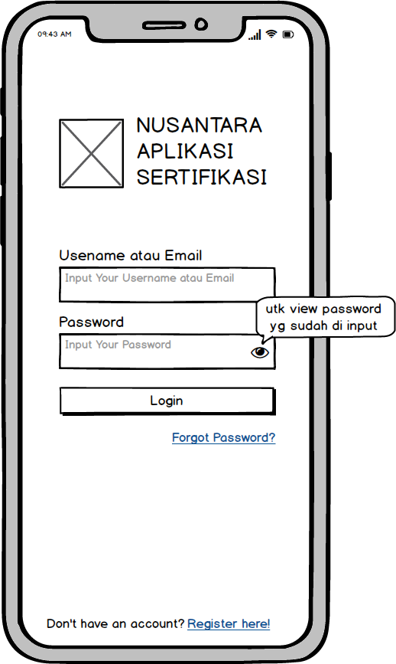

1. **Forgot Password** page

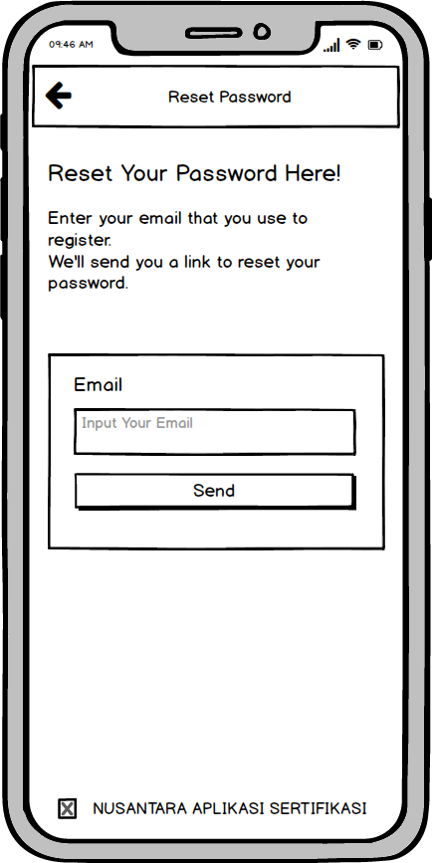

1. **Registration** Page

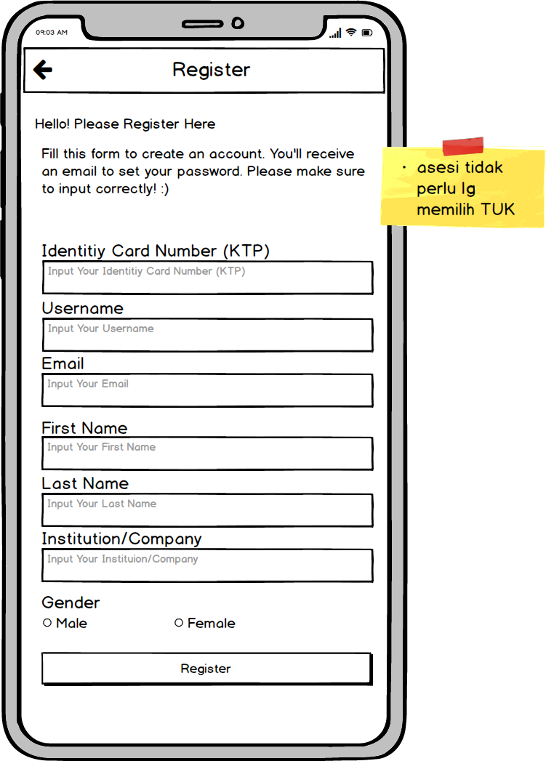

1. **Page Home/home**

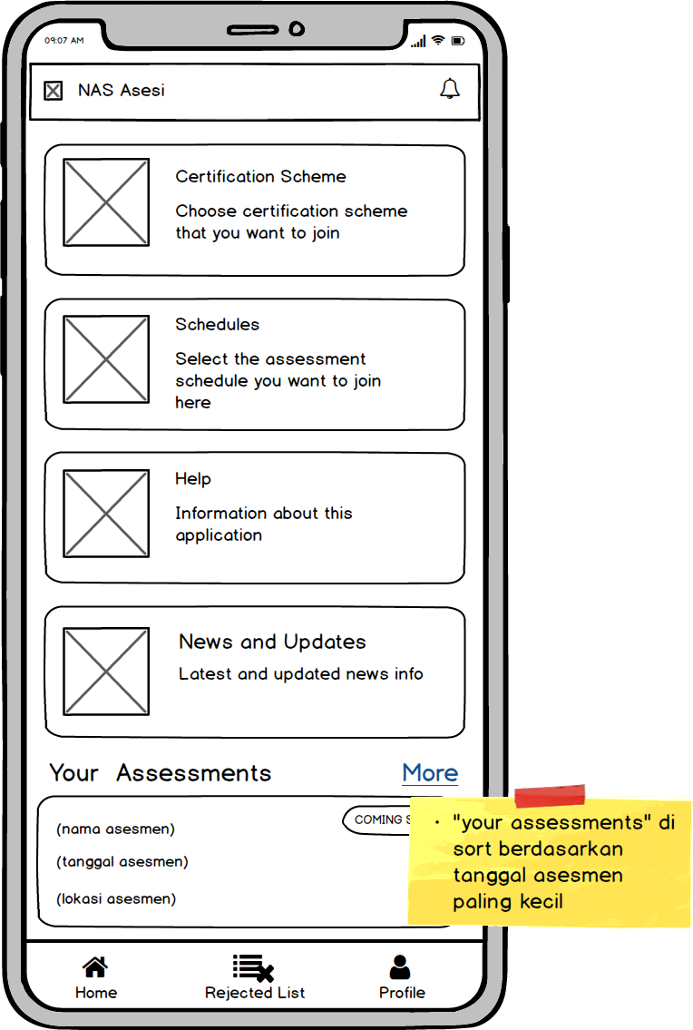

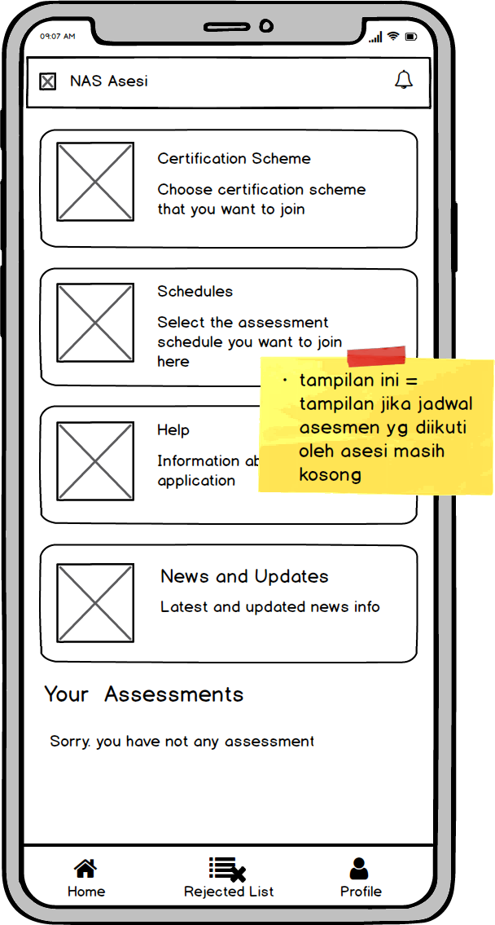

1. **Halaman “Your Assessments”**

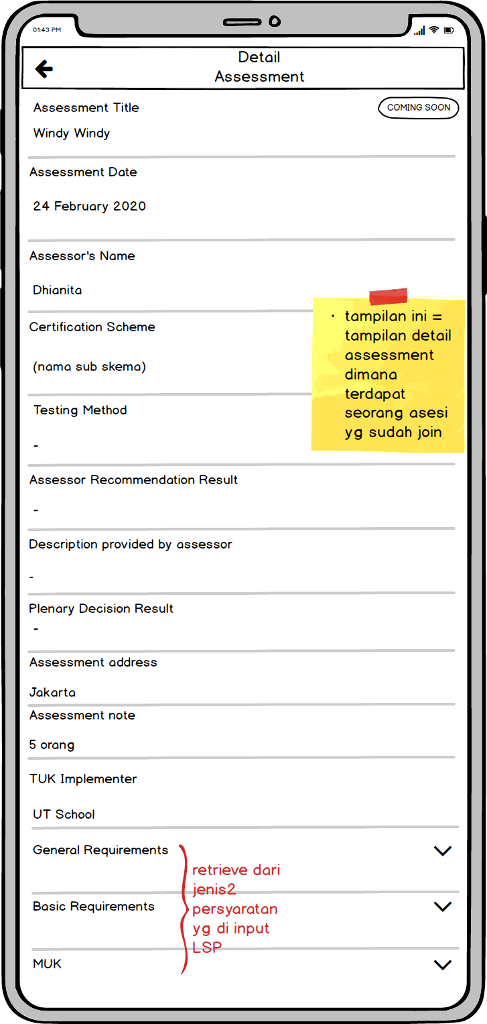

1. **Certification Scheme** page
2. **Certification Scheme** page



1. **Detail Certification Scheme** page

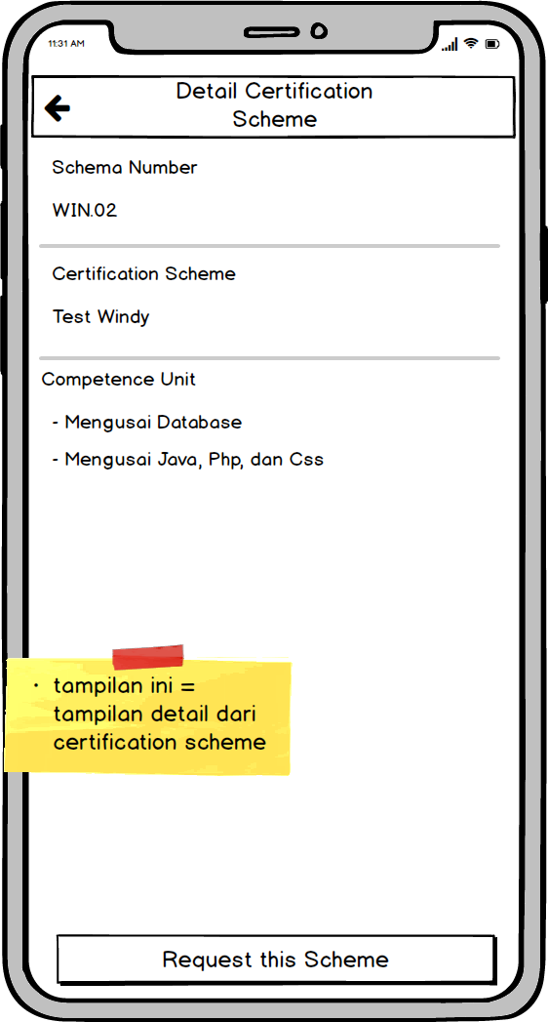

1. **Assesment**  **Schedule** page
2. **Schedules page/Jadwal**  **assesment** Schedule

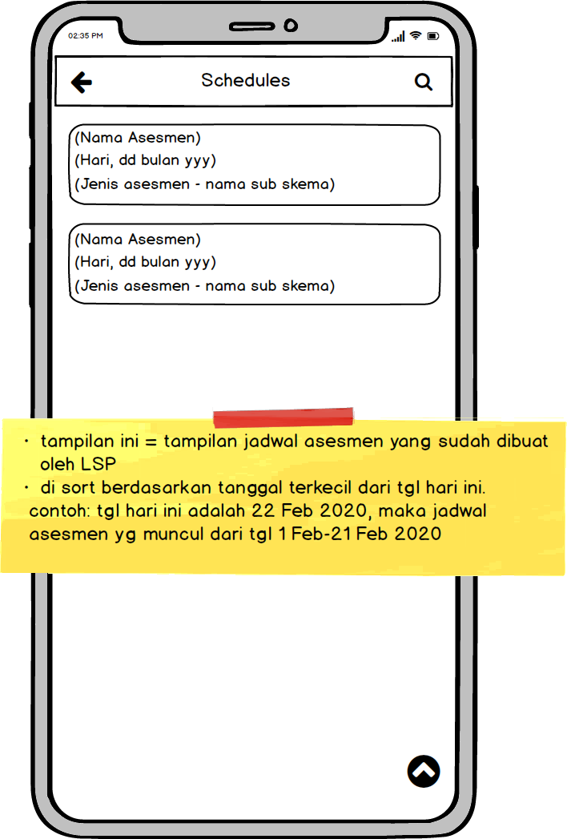

1. **The**  **Assessment** Detail page

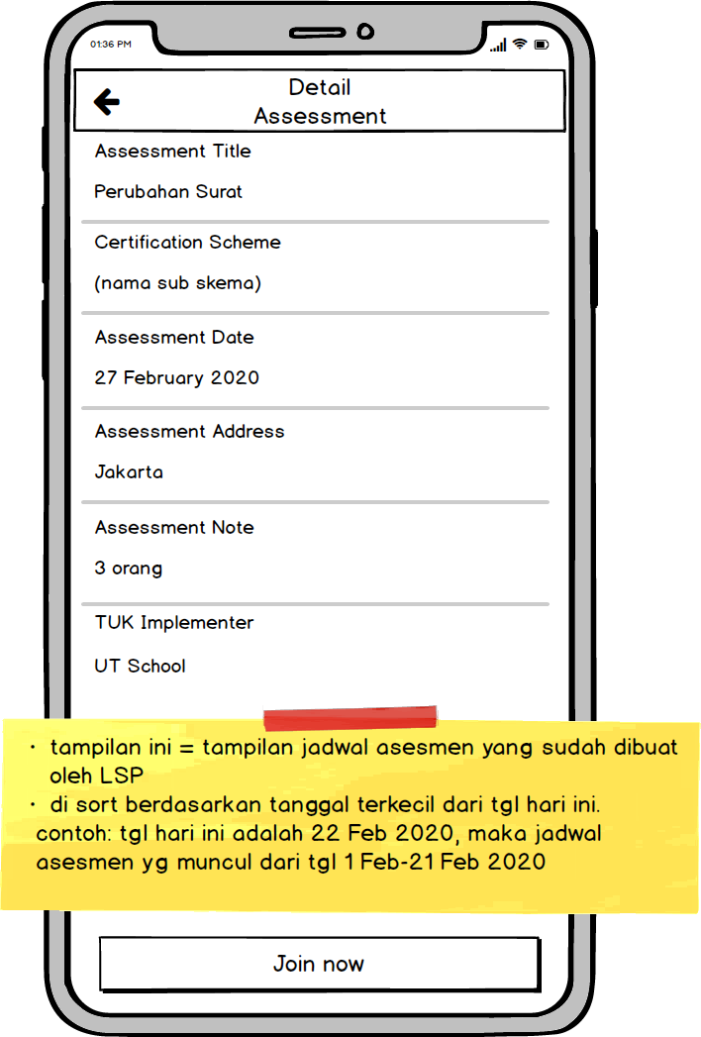

1. **Help** Page

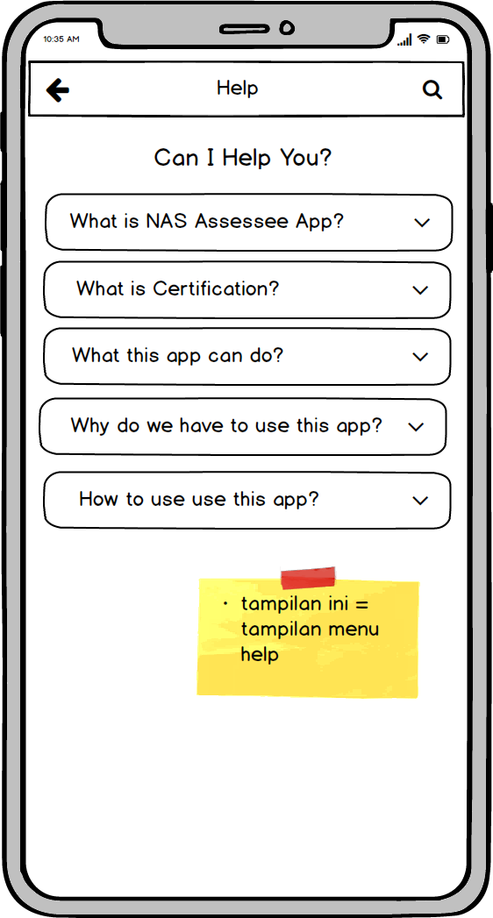

1. **News & Updates Page**

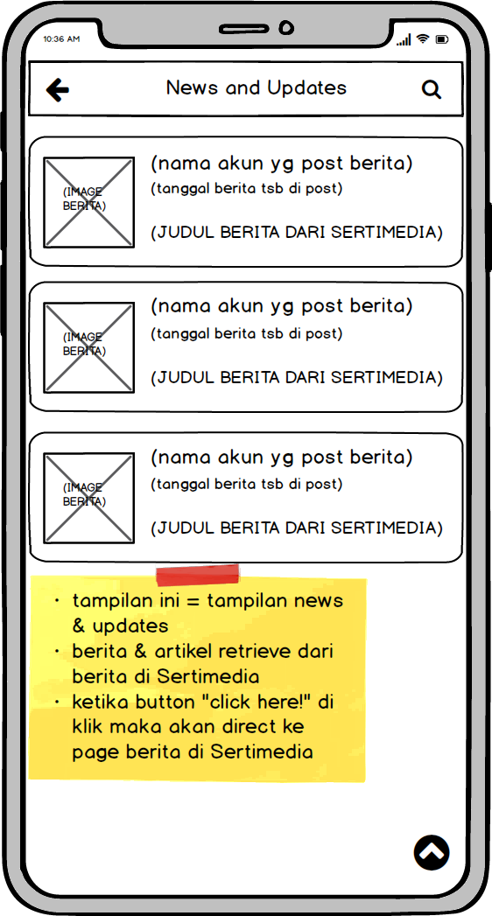

1. **Page Rejected List**
2. **Page** View **Rejected List**

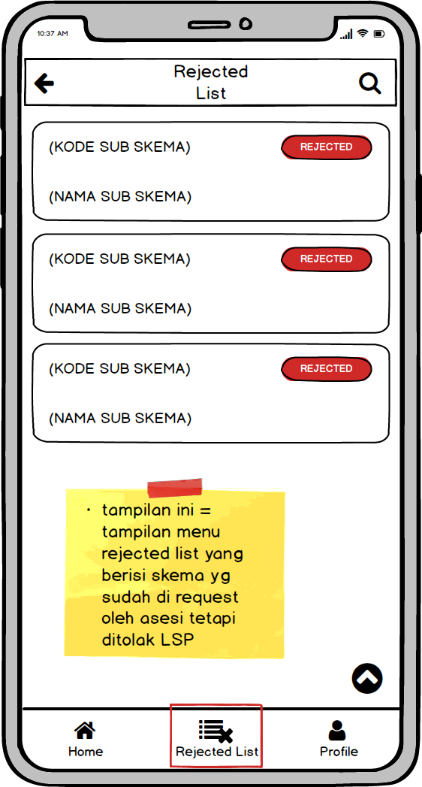

1. **Detail page**  view

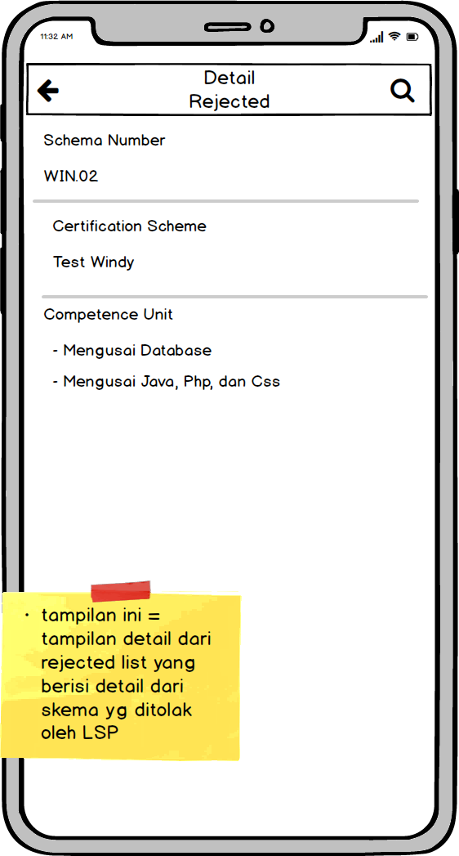

1. **Profile** Page

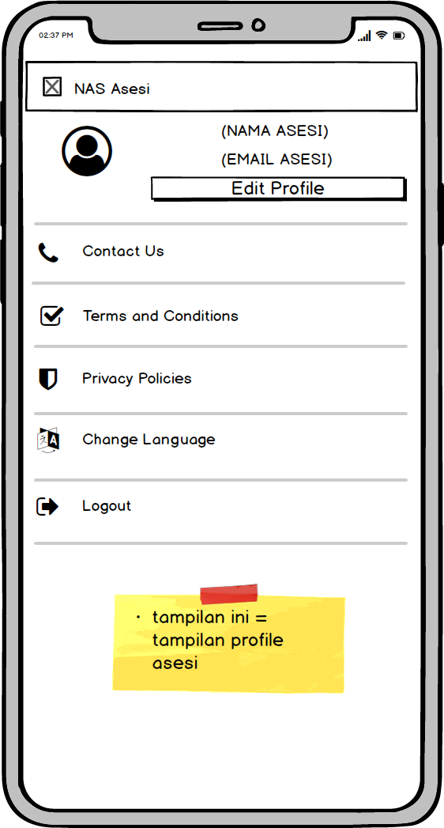

1. **Edit Profile Page**

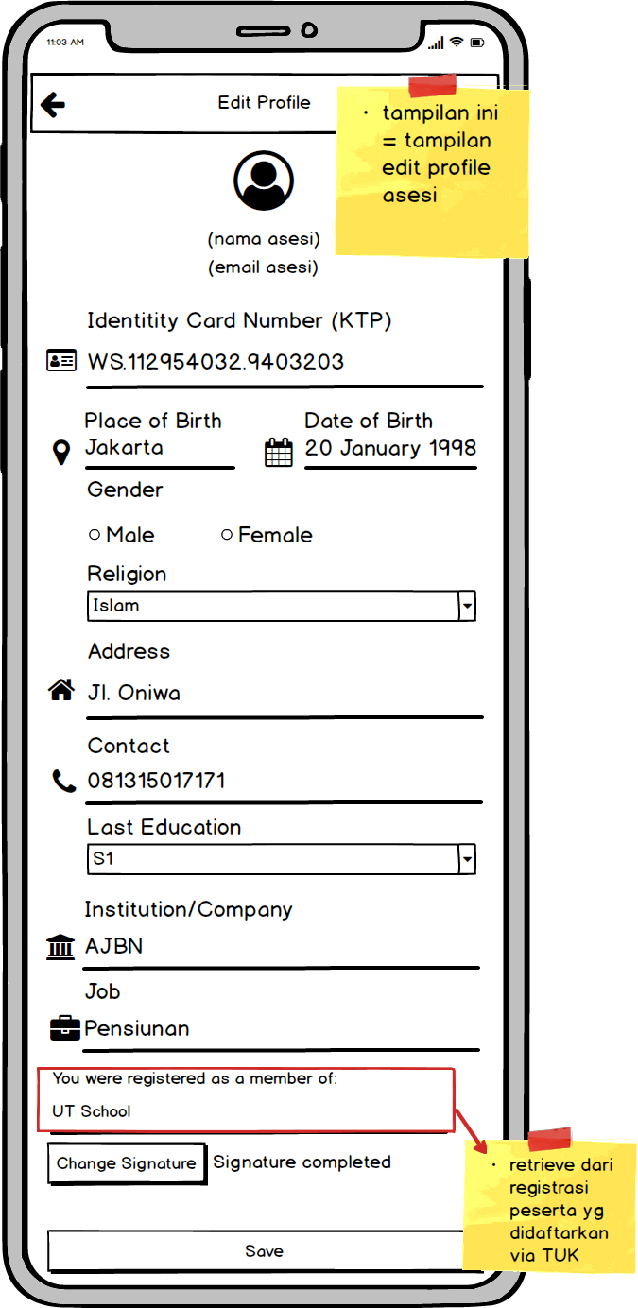

1. **Contact Us** page

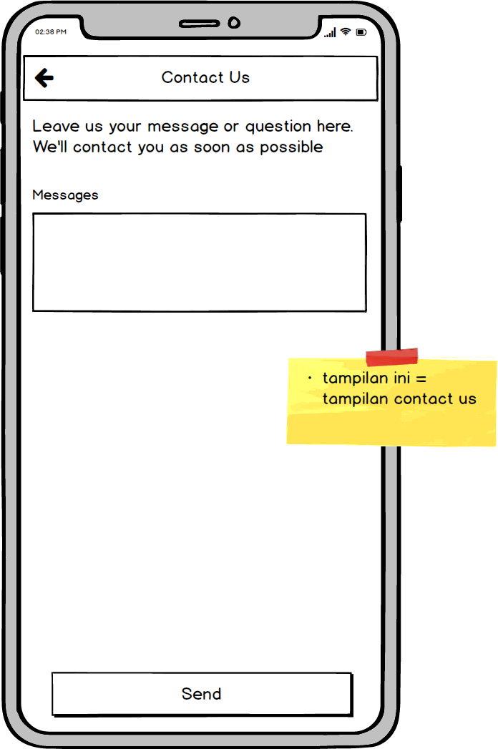

1. **Page T & C**
2. **Page T & C Asesi**

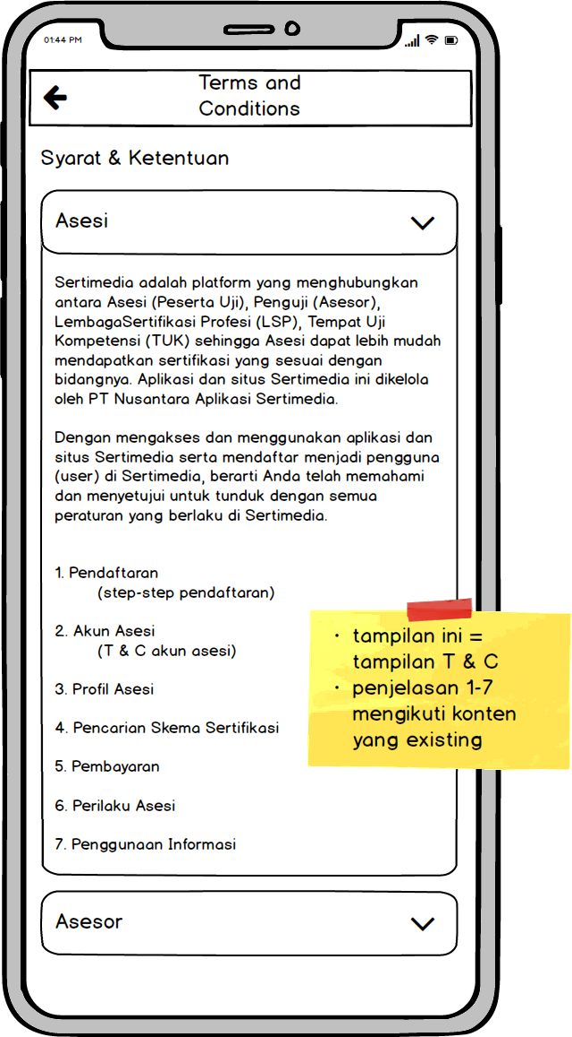

1. **Page T & C Asesor**

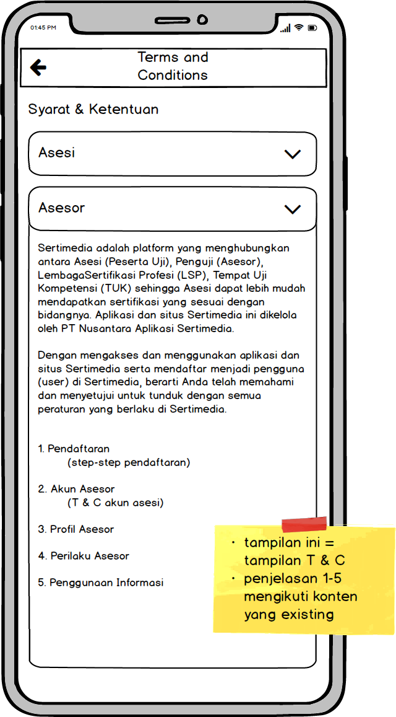

1. **Privacy Policies Page**

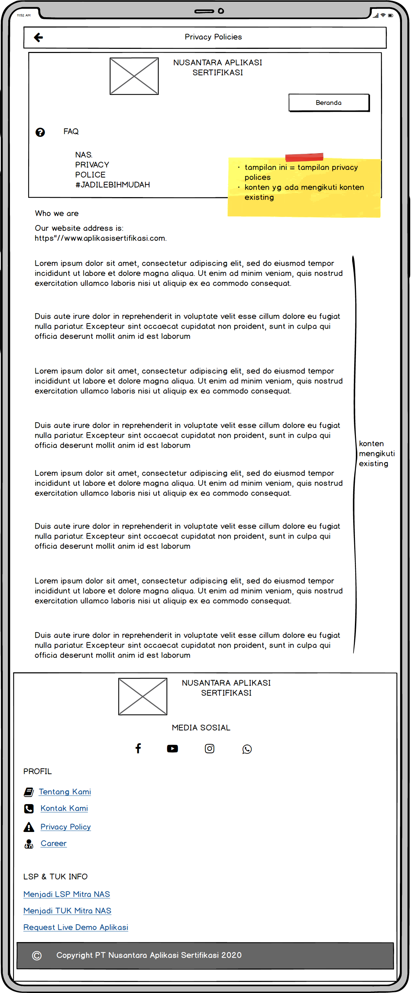

1. **Page Change Language**

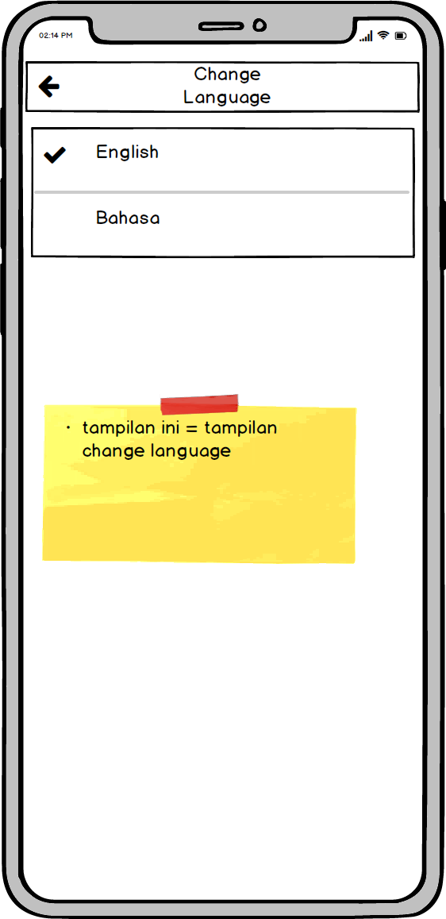

1. **Logout** Display

